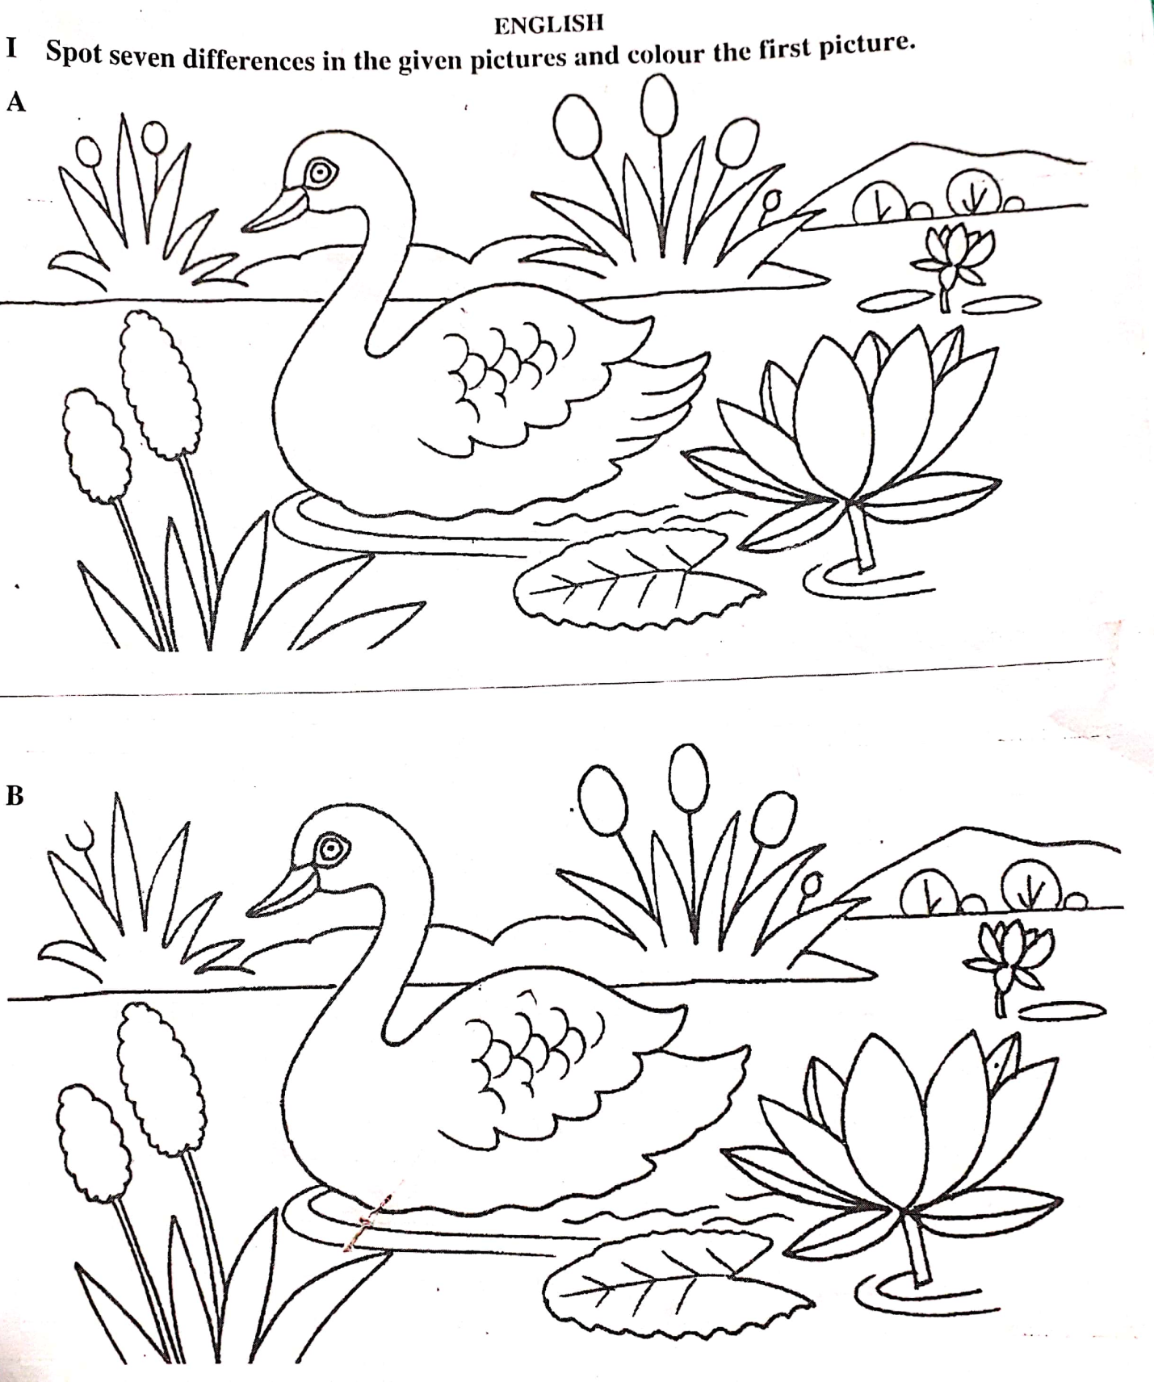
Page 1 of 12

II. Write the plurals of
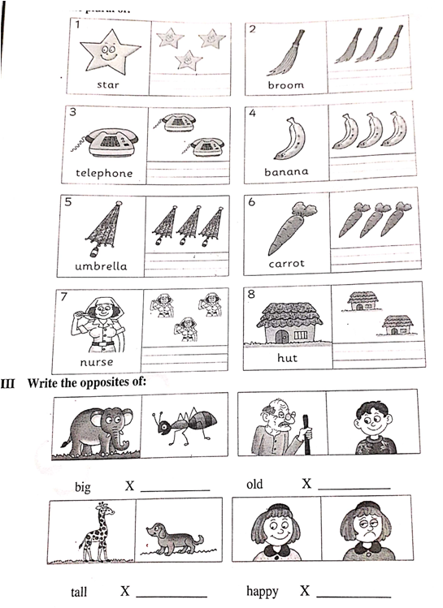 Page 2 of 12

IV. Find the name of 10 colours given ‘across’and ‘down’ from the grid and write them on the blanks
given below .
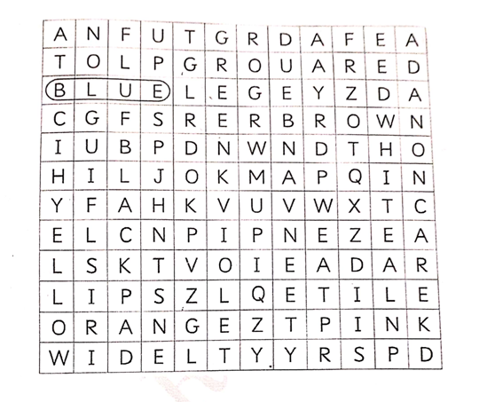
Across Down
Page 3 of 12

V. Unjumble the words,use’a’ or ‘an’ before them and colour the pictures.
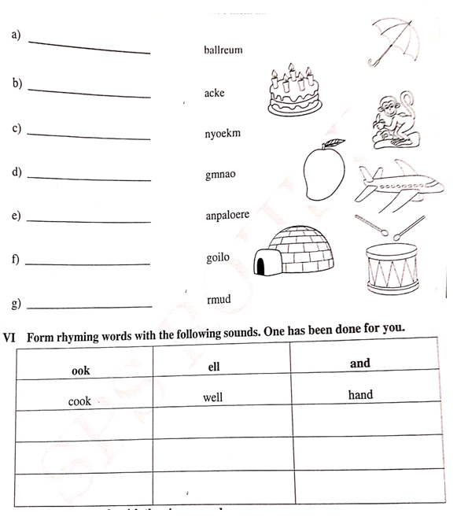
Page 4 of 12

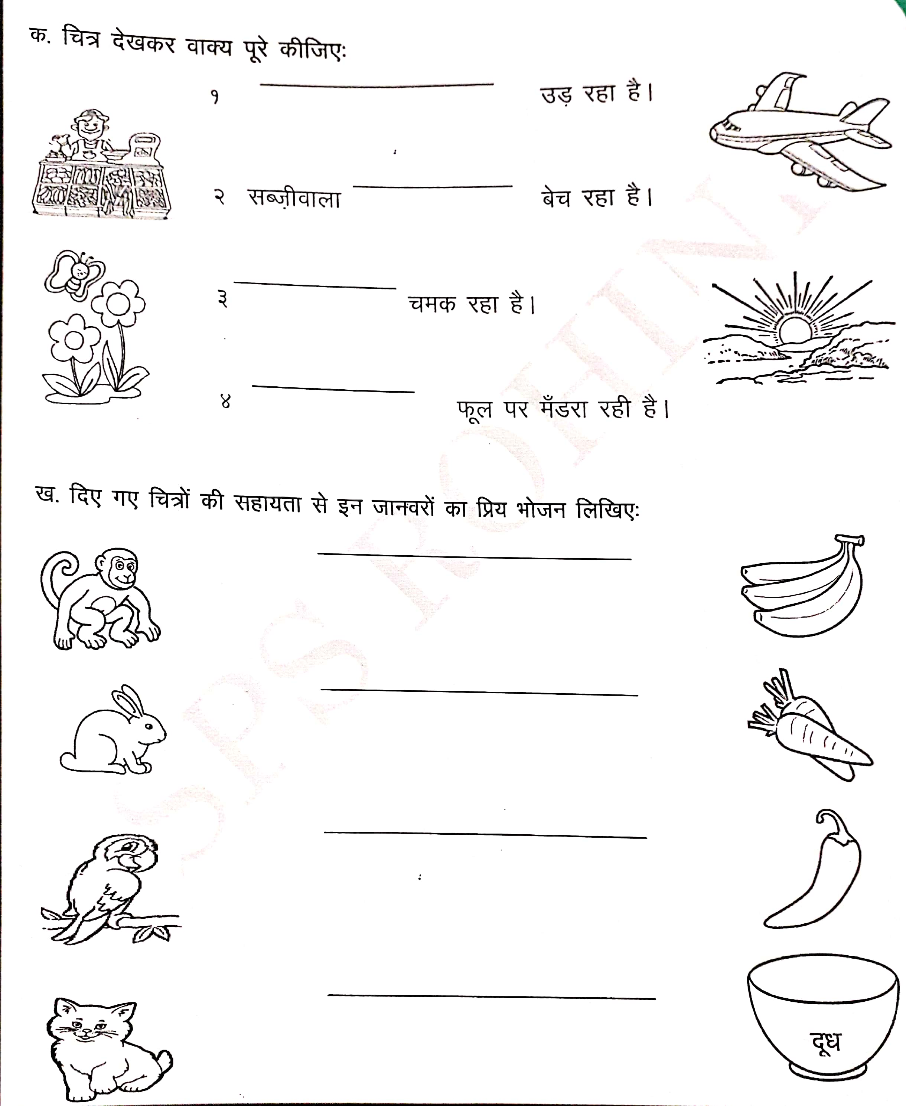

Page 5 of 12

x- foykse “kCn fyf[k, % 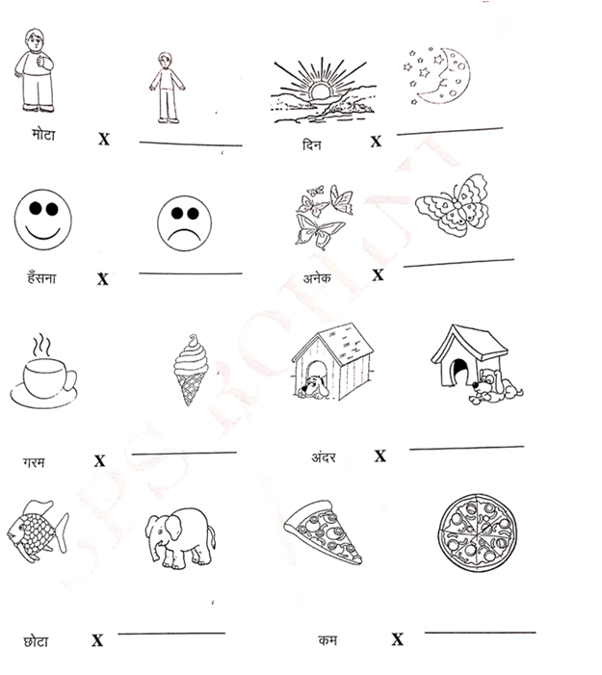 Page 6 of 12

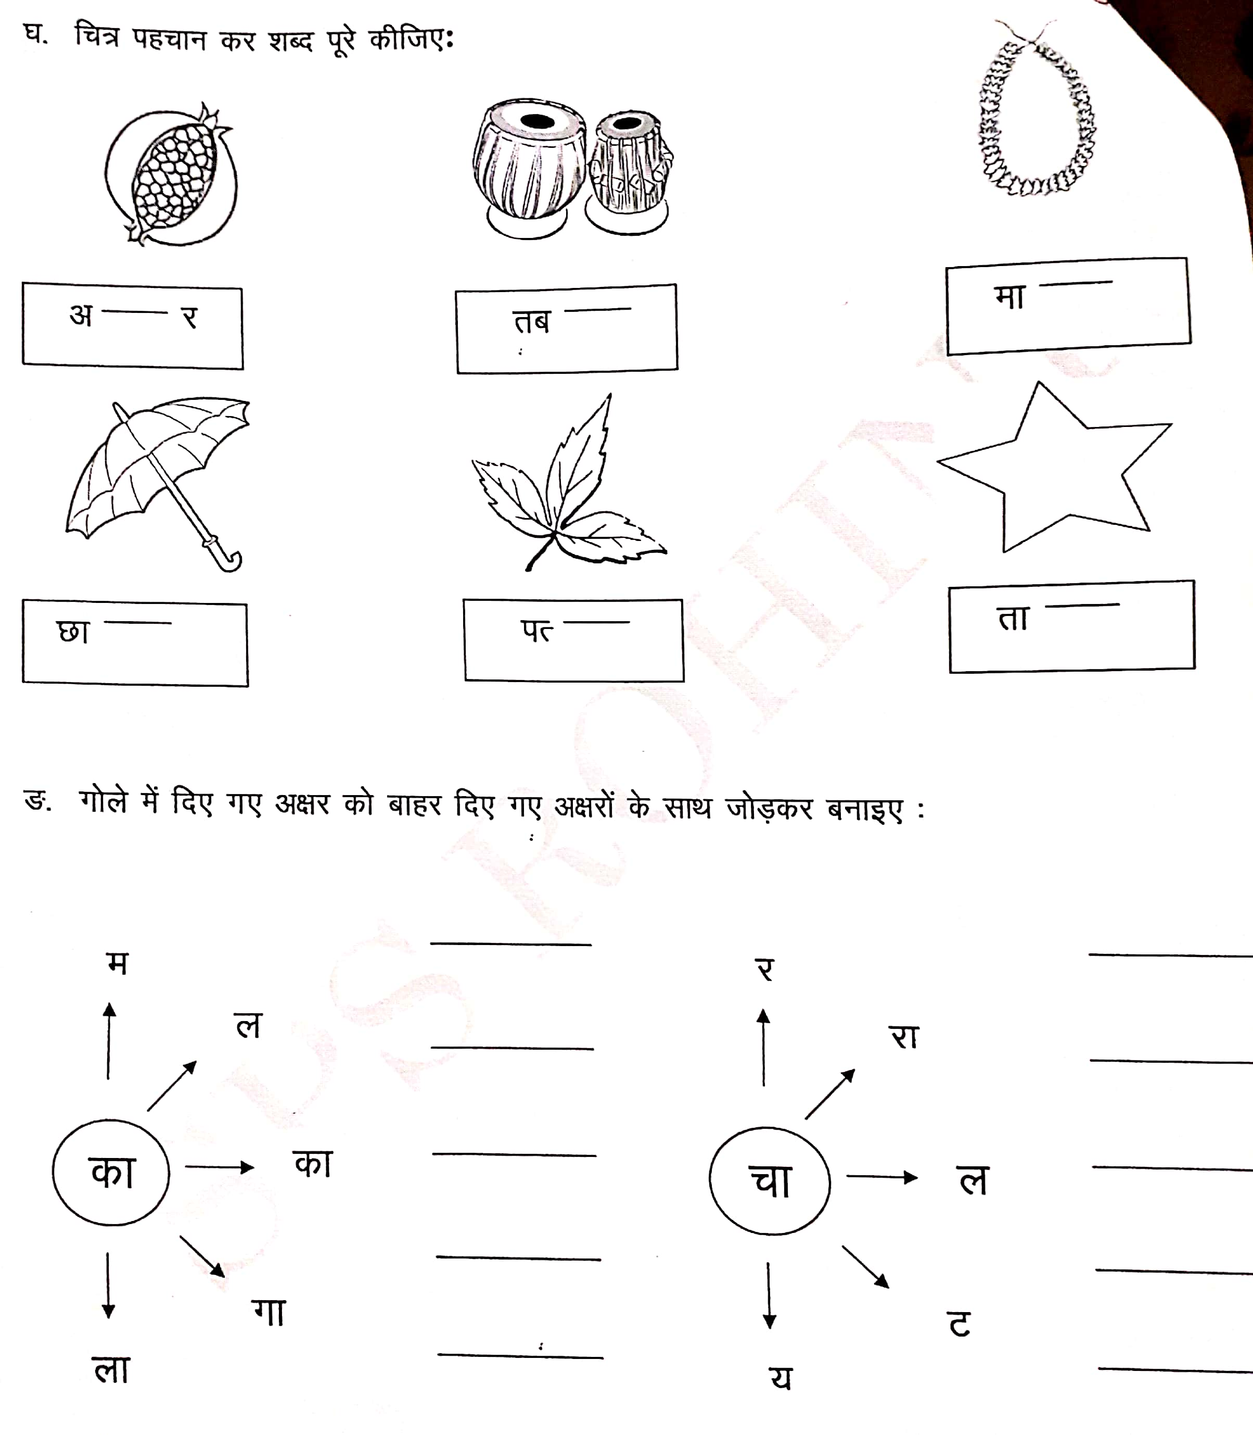
Page 7 of 12

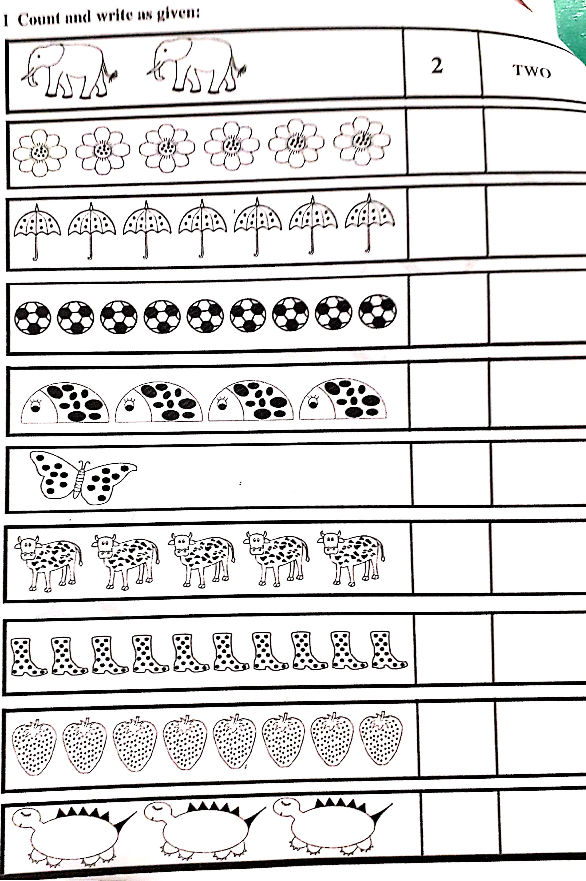
Page 8 of 12

II. Write the numbers in the grid and colour the boxes as per the instructions given below :
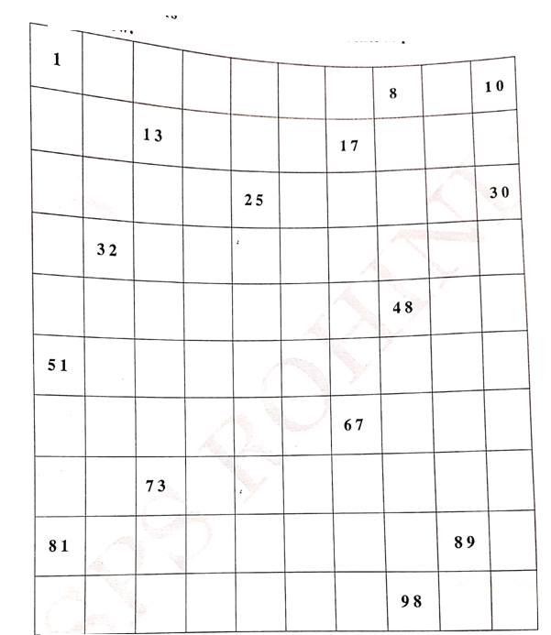
Colour the square showing and the picture :-
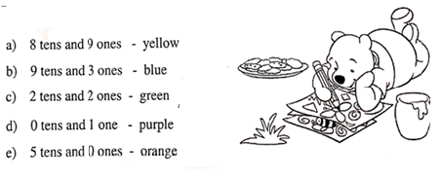
Page 9 of 12

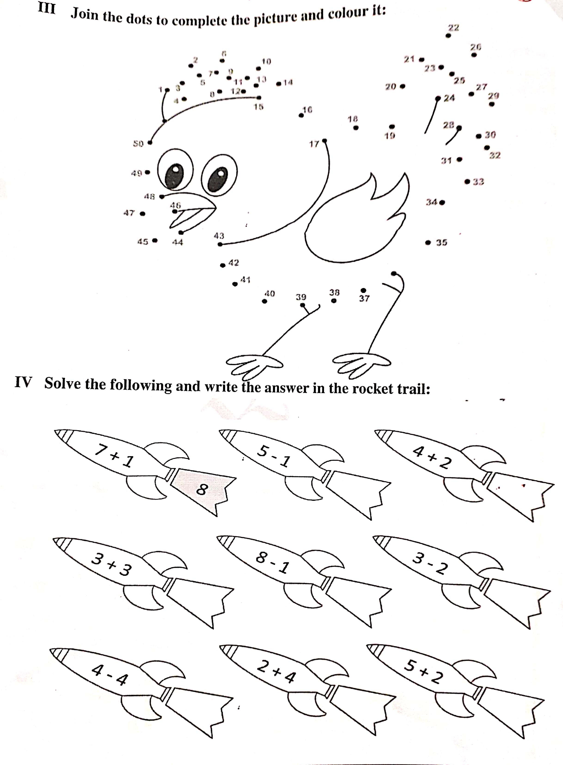
V. Write forward counting ( 0 to 100 ) in a spearate sheet .
Page 10 of 12

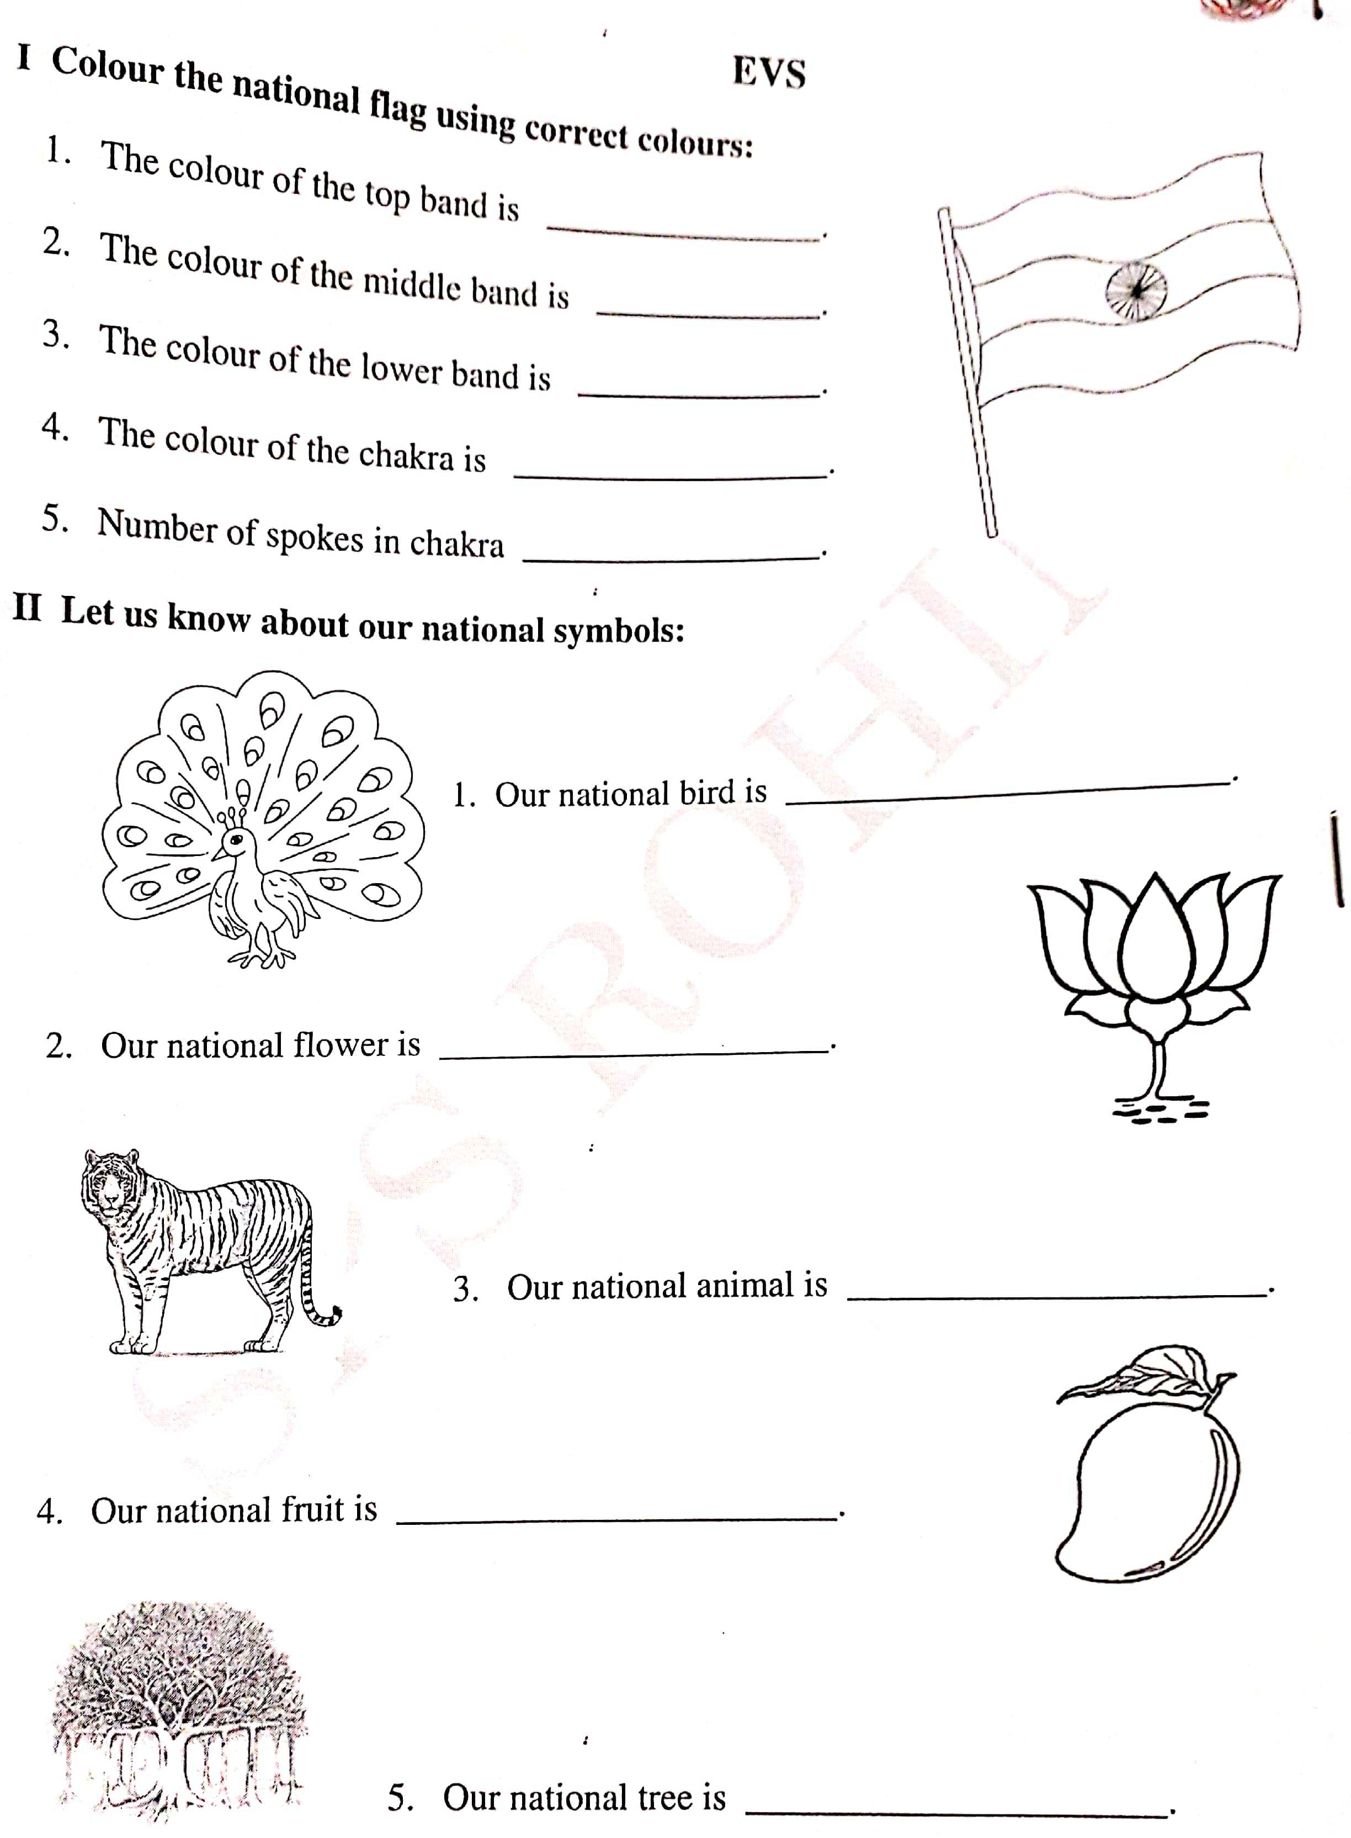
Page 11 of 12

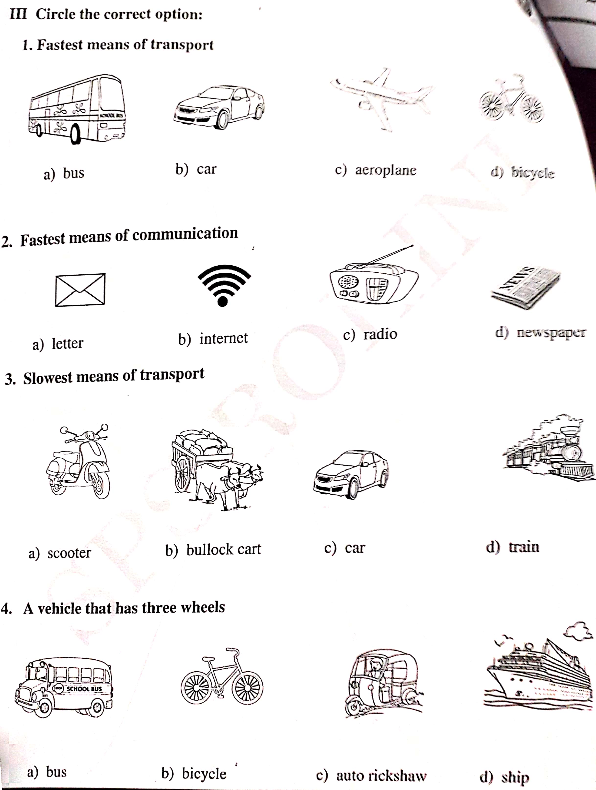
Page 12 of 12
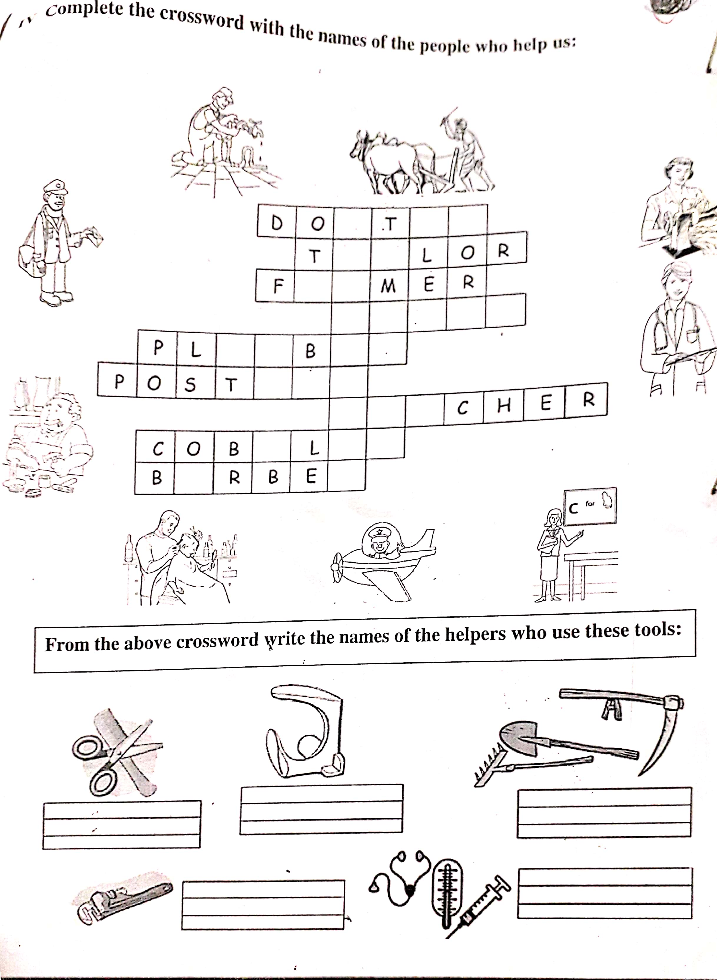

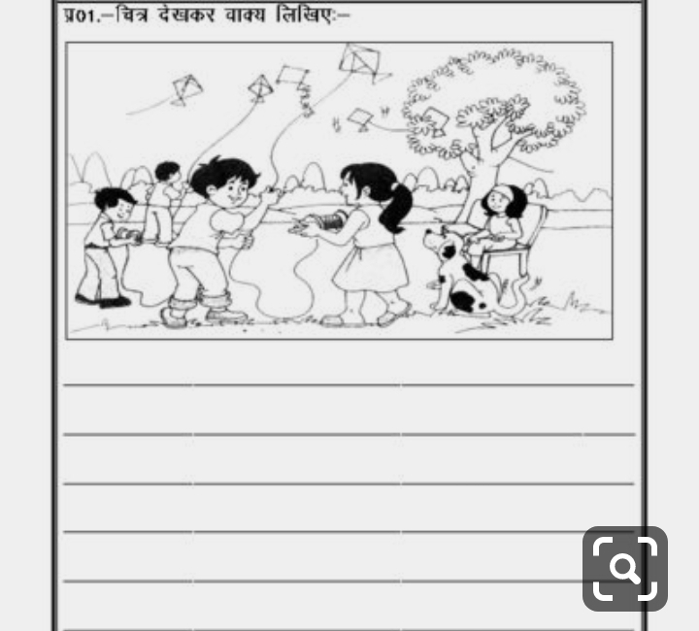

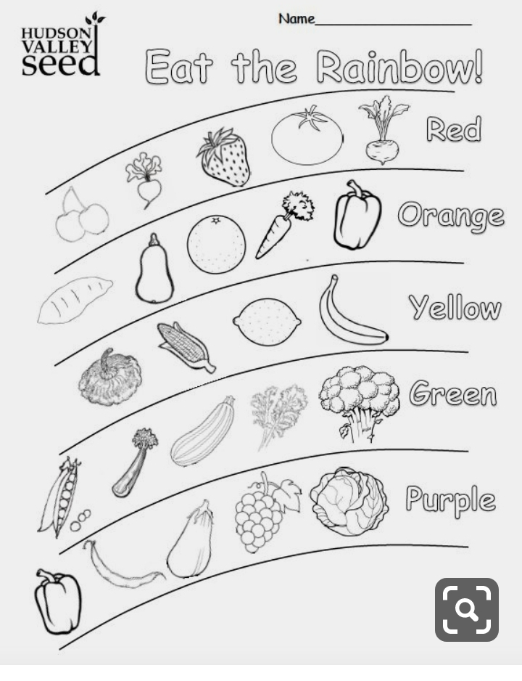
Page 13 of

